1. Introduction

The following checklist contains a series of questions that may or may not be applicable to your project. This is intended as a guideline to assist you in getting started on your project.

Your project charter and workplan will determine how good (or bad) life will be for you and your team over the course of the project. A good project plan uses the proper inputs, addresses good planning practices, and is positioned for ongoing use through the life of the project. Put sufficient effort into the plan and double-check it against a guideline, such as this checklist.

The following is intended as a guideline to assist you in initiating and planning your project.

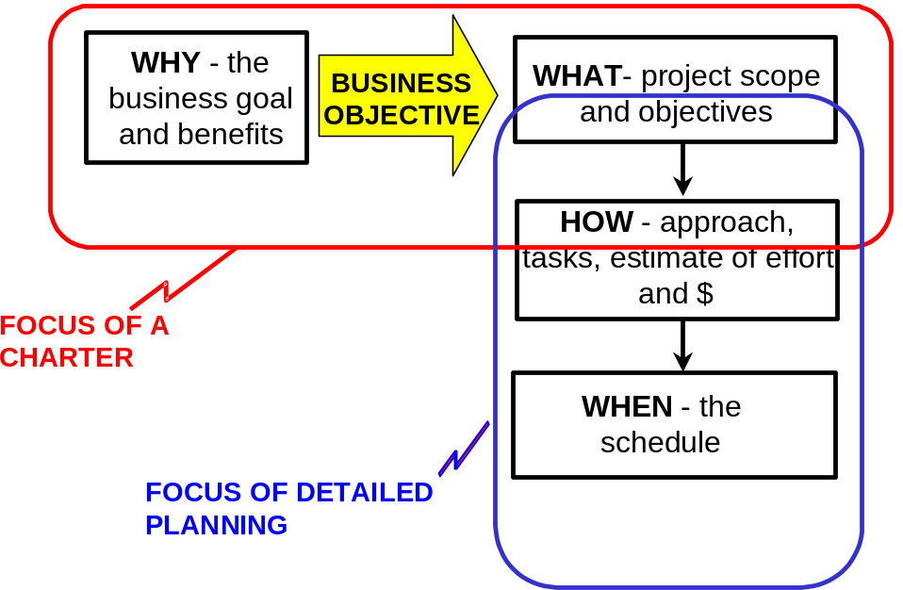

2. Project Charter

- Investigate who wants the project, determine the Sponsor
- Does the Sponsor understand and agree to the Project objectives, scope, risks and approach?
- Determine why they want the project, what the business drivers are, what the problems are that create the need
- Establish project objectives that support the business need
- Define the project scope, focusing on completeness, not detail
- Do some preliminary project planning to define how the work will be done and establish a budget
- Identify project risks, degree of impact and likelihood of occurrence, and mitigation activities
- Document Project Charter and obtain Sponsor approval

General Charter Questions:
- Have you provided a framework for reporting progress, managing change, and resolving issues?
- Is there a formal process defined for management to review project progress and approve key deliverables?
- Does charter define roles and responsibilities, approach and milestones?
- Does the Charter address risk in a comprehensive manner?

- Resource Commitments

- Have all required team members been assigned to the project, and is the organization aware of the dedicated need for their time?
It is important that management is aware of who is working on the project and for what percentage of their time. As a project manager you should be wary that part-time team members are typically pulled away on urgent matters to the extent that they are not able to work the full amount of time that they have been assigned to the project.
- Do you have alternatives for staffing your project if your best case is not possible? What compromises are you prepared to make that do not put the project at risk?
- Does the project team have the necessary equipment and office space to work?
- Does each team member know his role and understand the extent of his responsibility and authority?
- For larger projects, where a more rigid structure is desirable, organization charts are useful for clarifying roles.
- For smaller, more fluid projects, where it is typical for each team member to play multiple roles, it may be necessary to assure each individual that they are empowered to fill whatever roles are necessary to keep the project moving.
- Have you held a project kick-off meeting with your team?
Hold a meeting to bring the team together present the scope of the project and introduce individuals who will be filling roles in the project. Sometimes it is necessary to hold several kick-off meetings. A large project may have one for the project steering committee, another for business analysts, another several weeks later for developers when development is ready to begin, and still another for testers. At all kick-off meetings the format is the same: introduce the project and discuss its current status and how the individuals assembled will contribute to the project goal.

4. Schedule

- Have you identified the project phases, milestones and key outcomes? Have you identified the deliverables that will be produced in each phase? Do you know what they will contain?
- What is your strategy for obtaining buy-in and approval of those deliverables? Validating the deliverables?
- What skills do you require on your team to produce those deliverables? Validate those deliverables?
- How do you propose to organize your project team to deliver most effectively?
- What are the risks associated with the project? How could they affect the plan? Do you need contingency?
- Do the team members understand and agree to the steps shown to create the deliverables they are responsible for?
- Has the project team been involved in the estimation process?
The project team should have major input on how long it will take to develop the system. As project manager, your job is to ensure that the development estimates are reasonable, adding time to cover foreseen risks.
- Are occasional absences (both known and unknown) of team members due to vacations, training, meetings, illness, and other outages accounted for in the plan?
- Has each team member agreed to take responsibility for producing his/her assigned piece of the project within the time estimated?
All team members should be confident enough with the estimates to commit to performing each task in the time planned.
- Has the project manager agreed that all tasks are estimated realistically?
Since you have responsibility for bringing the project to completion in the time specified by the plan, it is important that you have confidence in each estimate. If you are not confident of the individual estimates then is there enough time allocated for 'contingency' to give you an adequate comfort level of the overall plan?
- Does the plan equitably and sensibly allocate time to the major phases of Requirements, Analysis, Design, Development, Testing and Deployment?
The above list represents the standard lifecycle activities of most software development projects. Check that your project plan has time for all of them. Most plans allocate time to development, but it is surprising how many leave out one or more of the others, often causing confusion and panic.
- Will the plan ensure creation of deliverables for clients at regular 2 to 3 week intervals?
A project with regular deliveries is inherently simpler to control than one that produces nothing until the very end. Each delivery is a concrete milestone that is visibly met or not met. Regular deliveries also allow users to give constructive feedback at critical intervals. Furthermore, this approach helps prevent a rash of integration, testing and deployment problems from appearing near the end of the project.
- Are all assumptions and external dependencies in the plan explicitly documented?
Because plans are drawn up early in the project lifecycle, there can be many unknowns, and assumptions need to be made in order to produce a schedule. All of this must be documented as part of the plan so that the plan can be modified appropriately should an assumption turn out to be false. A special kind of assumption is the external dependency, wherein the project plan assumes that some task external to the project is complete by a certain point in the project's progress.

5. CHARTER AND PLAN OVERVIEW

DOCUMENTATION ELEMENTS
X = element is usually introduced during this version. All elements may be updated subsequently.

Element | Charter  First version | Project Plan Second version | Comment
Business Purpose | X |  | High level goal served by project and the specific business objective in must achieve.
Project Objectives | X |  | Specific outcomes of project, using S.M.A.R.T. acronym.
Project Scope  Description  Deliverables | X  X |  | Narrative and list of deliverables.
In/Out  WBS |  | X  X | Final definition of the work to be done.
Approach | X |  | How the work will be done – the methods to be used.
Stakeholders | X |  | Who has an interest in the project?
Roles and Responsibilities | X |  | Responsibilities of the key stakeholders. May include a project structure chart and steering committee formation.
Budget  Allocation | X |  | If a budget allocation has been provided, state it here. Using ranges or uncertainty factors indicate degree of budget risk.
Estimates |  | X | Based on bottom-up build, provide project estimate of work effort and $.
Schedule  Critical Dates | X |  | If certain dates must be met, state them here. State the desired end date.
Dependencies  Milestones  Gantt |  | X  X  X | Especially reliance on others.  Key events.  Visual bar chart of schedule.
Resource Plan  Requirements  Resource Matrix | X | X | State critical skill and major facility needs.  Time phased (monthly) matrix of team member work effort.
Assumptions | X |  | Basis for estimate of effort and schedule.
Constraints | X |  | Certain conditions that must be adhered to.
Risks  Key Risks | X |  | Preliminary risk analysis to identify high priority risk events.
Mitigation Plan |  | X | Actions to address high and medium priority risk events.
Project Issues |  | X | Current impediments to success
Approvals | X |  | Process for approvals, what has to be approved, who approves.
Communications Plan |  | X | Who has to be kept informed and how.
Tracking and Time Reporting |  | X | Use of the time tracking system.
Progress and Status Reporting |  | X | How the team will report, and what reports will be provided to stakeholders.
Change Management |  | X | How changes to scope will be handled
Issue Management |  | X | How issues will be logged and escalated.
Quality Management |  | X | Key quality issues and the planned response.

